**Assignment Submission**

**Heading: Challenge 01**

**Approach:** Used the hint for the command but then checked the startup-config file to look for the user name and password and it was there.

**Solution:**

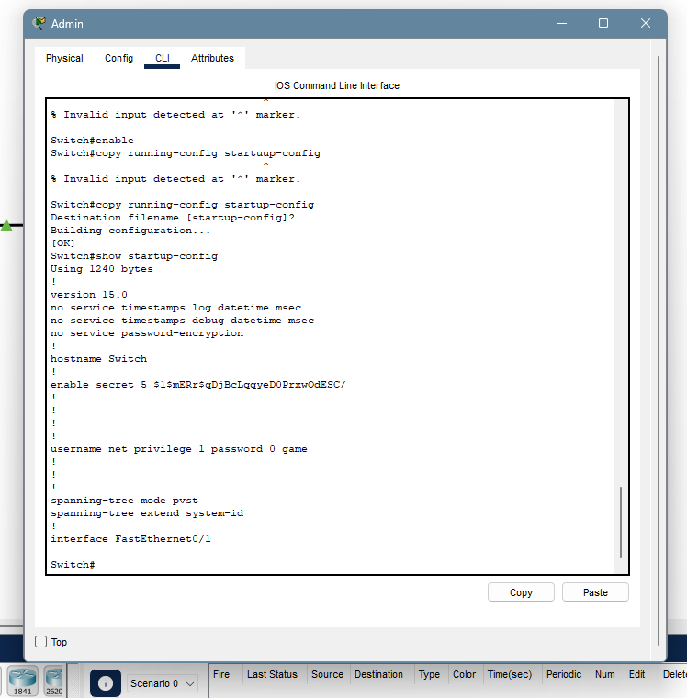

**Heading: Challenge 02**

**Approach:** not sure what I was meant to do here…I used the interface command here to learn about Ethernet 1 and changed its range too…the packets were being transmitted successfully as well…found the user and passed switch 1 to using the previous method(because that is what I understood from this assignment)

**Heading: Challenge 03**

**Approach:** Here I checked whether all the connected nodes were able to share traffic or not. There was a failed packet transfer between PCs 2 and 3 i.e. Bob and Vicer. So, to find the problem there. We only had to check whether that configuration was wrong or not which it was but I troubleshooter it as well. So, my first approach was to check VLANs and I immediately saw that ethernet 3 was not connected to vlan 2 in the 2nd SENIOR switch…so I used switch port commands to sort that out. Then packets were still not going so I switched one vlan to trunking because that could be the only reason for packet failure after setting the vlans correctly.

**Solution:** 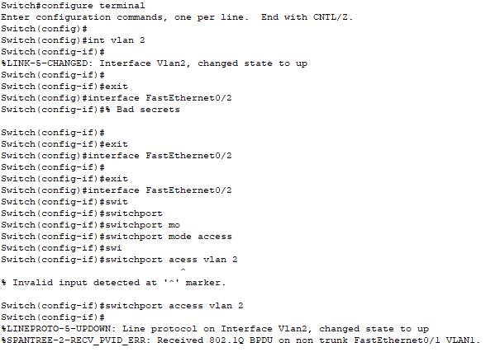

----------------------------------------------------------------

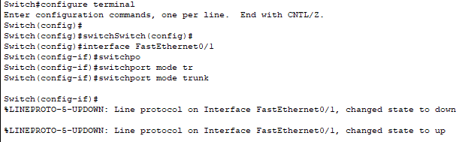

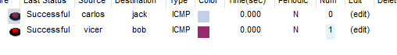

**Heading: Challenge 04**

**Approach: did the normal SSH approach**

**Solution:** 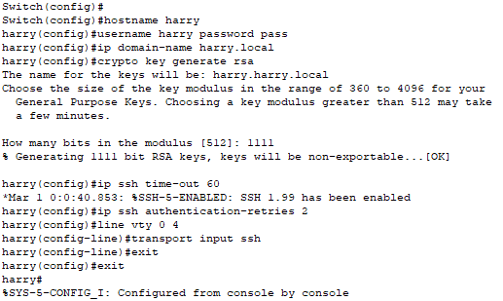

**Heading: Challenge 05**

**Approach:** Here there was a problem in sending packets to both PCs 2 and 3. So the first troubleshooting was easy. I just scrolled on the switch near to pc 3 and it showed that it was down. I simply went to the configuration of FastEthernet 0/3 and put in no shutdown command. It worked transfer was successful.

Then for the 2nd PC, I went to cli pf 3rd ethernet and did the same nothing happened. Then after time I shut shutdown and it said administrative down, and on no shutdown, it said only down…from there I remembered protocols…then I checked its interface status from the show interface for each ethernet for 0/1 it was a FULL duplex with 100 speed and for 0/3 it was HALF with 10 speed…I changed that up…and it was fixed.

**Solution:**

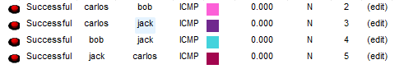

**Heading: Challenge 06**

**Approach:** I checked everything…all configurations…. everything was messed up…so I changed all IPs first to sort out the mess and matched the IPs of end PCs making 3 different networks like 10.0.1.1 / 10.0.2.1/ 10.0.3.1, etc……then I changed the VLAN IP address as well and sent the packets and no errors were there…successful transmission

**Solution:**

1`

**Heading: Challenge 07**

**Approach**: Straightforward approach…first thing I saw was that JACK PC was OFF. I turned it on…then went to the junior switched and checked its duplex and bandwidth because the vlan was correct…. duplex was half and the speed was 10… changed it to full and 100…the IP on the laptop was missing so gave it 10.0.0.20 which matched the network…. same duplex issue was in top most pc CARLOS…used the command **copy startup-config running-config** to check their status. Everything was sorted and worked fine.

**Solution:**

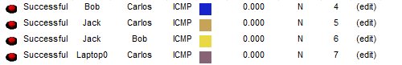

**Heading: Challenge 08**

**Approach**: Did the normal SSH process [one issue…while sending from the command prompt the SSh request, it says “connection refused by remote host”]

**Solution:**









**Heading: Challenge 09**

**Approach**: I did the time-out setting in the previous SSH configs as well. Timeouts can be set for different sessions…

**Solution:**

For SSH I used the command “IP ssh time-out 60” Here in both switches idle config was there…so I again set up SSH with this timeout configuration.

**Heading: Challenge 10**

**Approach**: First the ethernet 1 on the senior switch was down administratively…sp I had no shutdown command on it and it worked…then the Carlos PC had no IP…added IP to it. There were two Vlan i.e. 1 and 20…so I first gave IP to vlan 1 on senior and admin switch and just for self-practice I changed the vlan of junior according to ethernet connections with Vicer laptop and Carlos c to VLAN 20

**Solution:**

JACK AND BOB transfer data through Vlan 1

Viser and CARLOS transfer data through VLAN 20

